Sixth Form

Year 13 Revision Organiser

Effective Revision Techniques

- Turn off social media notifications

- Flash Cards: If you make revision cards you are selecting and reorganising the material you have learned which aids memory. If you would prefer to do this electronically rather than on paper you could use an app like quizlet.com.

- Past Paper Questions: It is essential that you test yourself doing past questions. Time yourself so you are prepared for the exam. A good benchmark when setting a time is ‘1 minute per mark’.
Past papers are on our subject google classrooms and Dr. Frost Maths.

- Graphic organisers (Venn diagrams, mind-maps etc): Using diagrams is an effective way to organize your thinking and the act of restructuring information proves more memorable than simply writing standard notes.

- Read-recite-review: If you need to learn quotations or facts, read the information, say it out loud. Then get a blank piece of paper and try and write them down from memory. Check what you have written is correct and repeat until you have got it.

- Use the ‘Cornell Method’ for revision notes: This strategy is really easy, it gets you to organise your revision notes in a structured way and helps long-term memory retention. If you use the link below there is a 2 minute video to explain this.
https://www.youtube.com/watch?v=4vOsVKWeyAA

DON’T simply re-read your notes or a textbook and
DON’T simply highlight text:
DO create something with the information to help it stick!

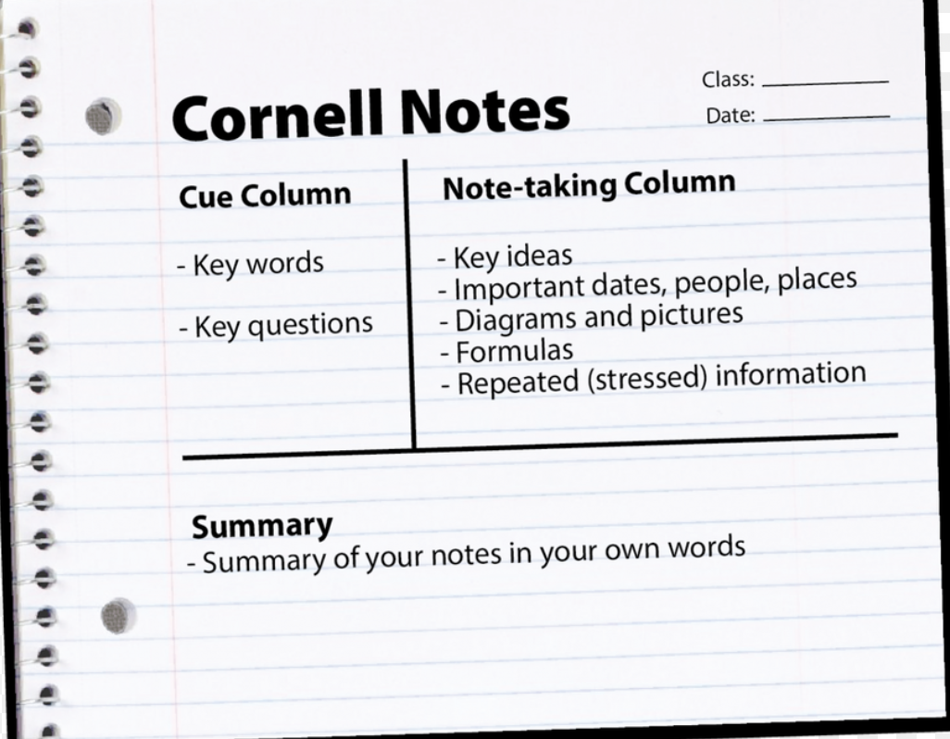

Space out your revision > Revise in bite size chunks > Mix it up, spending a little time on each subject in a revision session.

- Create a revision timetable
- Know your exam dates
- Make sure you have all the resources you need – stationery, revision guides, textbooks, notes, websites
- Revise each topic as you go
- Keep your notes in order to make it easier to find answers
- Download past papers and mark schemes
- Revise with a partner

A Level Mindset

- You can’t rely on your natural ability
- How well you know the content comes with the hours spent learning it
- Past papers are good practice
- Hard work means results
- Be aware that others around the UK are putting in the hours

Reflect on the positive

- Make a to do lists
- Have a routine
- Set time reminders
- Have a study timetable
- Manage distractions
- Set times for breaks
- Make Posters
Useful Apps and websites for revision

- Dr Frost Maths

- Craig David.org for computer science

- https://www.kerboodle.com/

- https://www.alevelphysicsonline.com/

- https://www.physicsandmathstutor.com/physics-revision/a-level-aqa/

- http://www.a-levelchemistry.co.uk/

- https://getrevising.co.uk/resources/aq

- https://www.learnoutloud.com/Podcast-Directory/Science/Biology

Gojimo
Doing practice questions is one of the best ways to revise for your exams, so why not try Gojimo, an app containing over 40,000 practice question for GCSE and A-Level. It has questions from every major exams boards, across multiple subjects, making it a great preparation tool.
http://www.gojimo.com/

The MindMeister Study App
Mindmap diagrams are an excellent revision tool for A-levels. They help to condense and visualise complex information, clarify thoughts and improve understanding and recall. It enables you to create mind-maps quickly and easily.
https://www.mindmeister.com/mind-maps/apps-download

StudyBlue Flashcards & Quizzes
This is a neat little study app that allows you to use electronic flashcards as study aids. You can create your own aids or draw from StudyBlue’s library of over 500 million user-generated cards.
https://www.studyblue.com/
Time | Subject | Topic | Tick when completed

Subject Revision Log
Subject ____________________________________________________
Key Topic Area | Revised | Revised for PPE Exams | Revised for Final Exams
Name

Paper:
Name

Paper:
Name

Paper:
Name

Paper:
What should I expect in the exam?
Subject | Structure of Papers |  | Date of exam | Main topics to revise
 | Monday | Tuesday | Wednesday |  | Thursday | Friday
Lesson 1
Lesson 2
Lesson 3
Lesson 4
Lesson 5
Lesson 6

5pm-6.30pm
6.30pm-8pm
8.00pm-9.30pm

 | Saturday | Sunday
9.30am-11am
11am-12.30pm
12.30pm-2pm
2pm-3.30pm
3.30pm-5pm
5pm-6.30pm
6.30pm-8pm

Remember to include rest breaks, leisure activities and work

My Schedule
Time Management Method the ABC daily to-do

- Write out your daily to-do list the night before. Write everything you want to accomplish.
- Label each task A, B and C
- A’s on your list are those things that are most important – homework due to other jobs which need to be completed
- B’s on your list are important, but less so than your A’s someday! These tasks are important but not urgent
- C’s do not require immediate attention – C priorities are often small, easy jobs
- Schedule time for all the A’s. The B’s and C’s can be done in odd moments during the day
Avoid C fever! Sometimes we want to do the easier tasks first but stick to your schedule! Pin your schedule up!
Create a schedule of activities for the weekend and label them A, B and C

